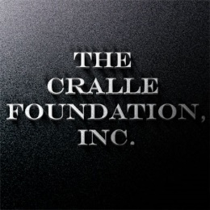
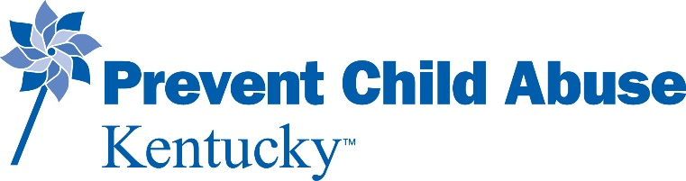

Building Positive Fatherhood Engagement through Community Support
Mini Grant Application
Prevent Child Abuse Kentucky (PCAK), in partnership with The Cralle Foundation, Inc., will award eight agencies or organizations funds (up to $500) to conduct an event focused on promoting positive father engagement. These events should provide resources/activities directly to dads and their children. Applicants may choose to propose in person or virtual events. Organizations serving communities within the Cralle Foundation service area will be considered for funding.
Eligible Communities:
Bullitt
Hardin
Henry
Jefferson
Oldham
Shelby
Spencer
Trimble
Contact Information:
Applicant Organization:
Contact Name:
Address:
Phone:
Email:
Project Name:
Projected Date of Activity/Event:
County:
Submit applications via email to dthomas@pcaky.org. Submission deadline is 5:00 PM ET, Friday, May 6, 2022.

If awarded, applicant agrees to:
- Schedule event/activity and expend awarded funds by the end of June 2022.
- Participate in a 90-minute fatherhood training. Certificate of completion and Social Work CEUs will be awarded. (Date TBD)
- Submit a photo(s) of the event/activity to dthomas@pcaky.org upon completion.
- Ensure all promotional materials and publicity include the Cralle Foundation and Prevent Child Abuse Kentucky logos and are submitted to dthomas@pcaky.org for approval prior to distribution.
- Submit an evaluation report at the conclusion of the project, no later than June 15, 2022.
Project Description:
In no more than two paragraphs, please describe your activity or event. Events must involve fathers in the community to promote positive father engagement. Inclusion of mothers and children is encouraged in proposed events, however, events solely for dads and/or male caregivers will receive equal consideration. Events could include, but are not limited to, a trivia/game night for dads and their children, a community outing with dads (e.g., baseball game, read-a-thon.) Project descriptions should address the following: 1) the number of fathers to be served, 2) if this is a new activity or enhancement of current programming, and 3) possibilities of sustainability beyond this mini grant.

AGREEMENT: It is understood if award is granted, it is as a result of this request, and will be used for the purposes set forth in the enclosed application. The undersigned agrees the implementation of this project will follow the aforementioned criteria and be relevant to child abuse prevention in Kentucky.
Submitted by:

For Applicant Organization Date

